**CONJOINT ANALYSIS**

Product profiles : combinations of these attributes A linear model fit to preference rankings is an example of *traditional conjoint analysis,* a modeling technique designed to show how product attributes affect purchasing decisions. Product profiles are defined by their attributes. By ranking, rating, or choosing products, consumers reveal their preferences for products and the corresponding attributes that define products. The computed attribute importance values and part worths associated with levels of attributes represent measurements that are obtained as a group or jointly—thus the name conjoint analysis.

When doing conjoint analysis, we utilize *sum contrasts*, so that the sum of the fitted regressioncoefficients across the levels of each attribute iszero. The fitted regression coefficients representconjoint measures of utility called *part-worths*.Part-worths reflect the strength of individualconsumer preferences for each level of eachattribute in the study. Positive part-worths add to aproduct’s value in the mind of the consumer.

Negative part-worths subtract from that value. When we sum across the part-worths of a product, we obtain a measure of the utility or benefit to the consumer.

The relative importance of attributes in a conjoint analysis is defined using the ranges of part-worths within attributes.

Traditional conjoint analysis represents a modeling technique in predictive analytics. Working with groups of consumers, we fit a linear model to each individual’s ratings or rankings, thus measuring the utility or part-worth of each level of each attribute, as well as the relative importance of attributes.

Conjoint measures can be used to predict each individual’s choices in the marketplace. Furthermore, using conjoint measures, we can perform marketplace simulations, exploring alternative product designs and pricing policies.

Consumers reveal their preferences in responses to surveys and ultimately in choices they make in the

marketplace.

Managers often ask about what drives buyer choice. They want to know what is important to choice or which factors determine choice. To the extent that buyer behavior is affected by product features, brand, and price, managers are able to influence buyer behavior, increasing demand, revenue, and profitability.

Ask buyers what they want, and they may say, *the best of everything.* Ask them what they would liketo spend, and they may say, *as little as possible.*There are limitations to assessing buyer willingnessto pay and product preferences with direct responserating scales, or what are sometimes

called self-explicative scales. Simple rating scale items arranged as they often are, with separate questions about product attributes, brands, and prices, fail to capture tradeoffs that are fundamental to consumer choice. To learn more from buyer surveys, we provide a context for responding and then gather as much information as we can.

**#Setting the Working Directory:**

**setwd("D:/Conjoint Analysis")**

**#Loading Library:**

library(readxl)

library(conjoint)

library(dplyr)

**#Loading Survey Score Results:**

Survey_raw <- read_excel("Conjoint_raw_data_30042020.xlsx",sheet=1)

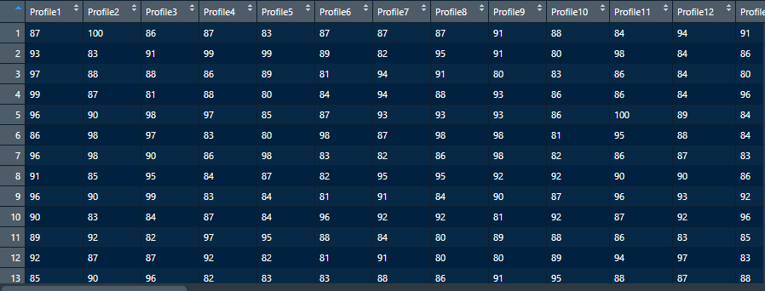

**#Arranging the Survey Result Data in Longitudinal Format:**

Survey_conj <- pivot_longer(data=Survey_raw,cols=Profile1:Profile49,names_to = "name",values_to = "Rating") %>% select(Rating)

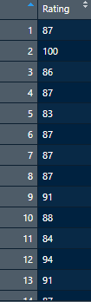

**#Profile (Plausible combination of Variable Level)**

Profiles <- read_excel("Conjoint_raw_data_30042020.xlsx",sheet=2)

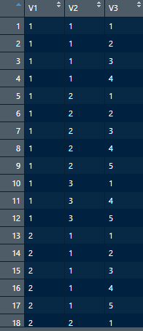

**#Variable Levels:**

levels_var <- read_excel("Conjoint_raw_data_30042020.xlsx",sheet=3) %>% select(Levels)

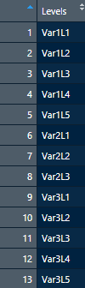

#Conjoint Analysis----

library(conjoint)

**#For one line in the survey result only**

caModel(y=Survey_raw[1,1:49],x=Profiles[,1:3]) #1:3 represent the coded attribute level numbers in the data table

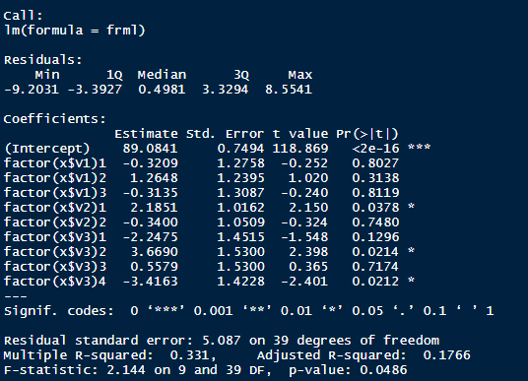

See the Pr with star, for the first person, V2 level 1, Var3 level 2, Var3 level 4 are most important.

**#For full model and data in the survey result**

Conjoint(as.data.frame(Survey_conj[,1]),as.data.frame(Profiles[,1:3]),z=levels_var[,1])

